Duplicate Cirtificate : Go To Duplicate Cirtificate
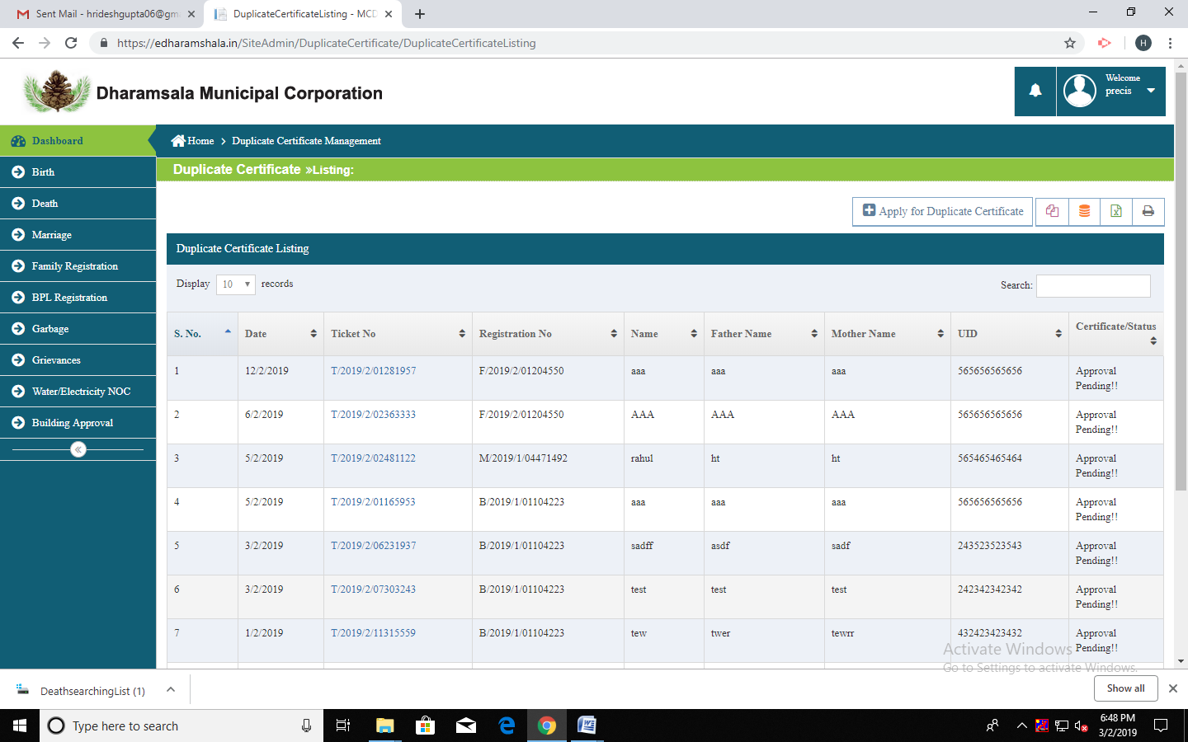
- Apply To Duplicate Cirtificate
